Galactic Astronomy Assignment Week1
陈平 Chen Ping 1501110226

- Download and read the Week 1 Notes. Done.
- Install scientific Python. I have python 2.7 on my computer
- Become familiar with scientific Python.

- Read a Table and Plotting

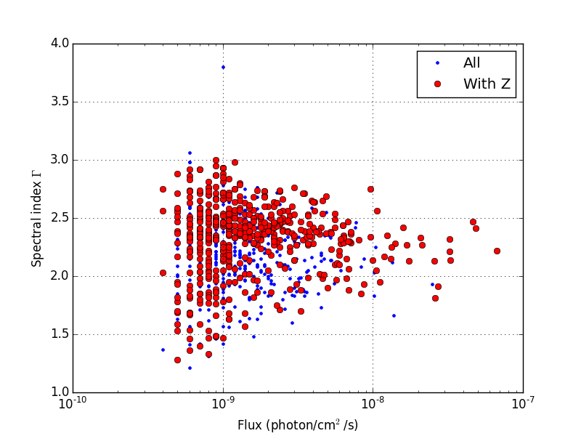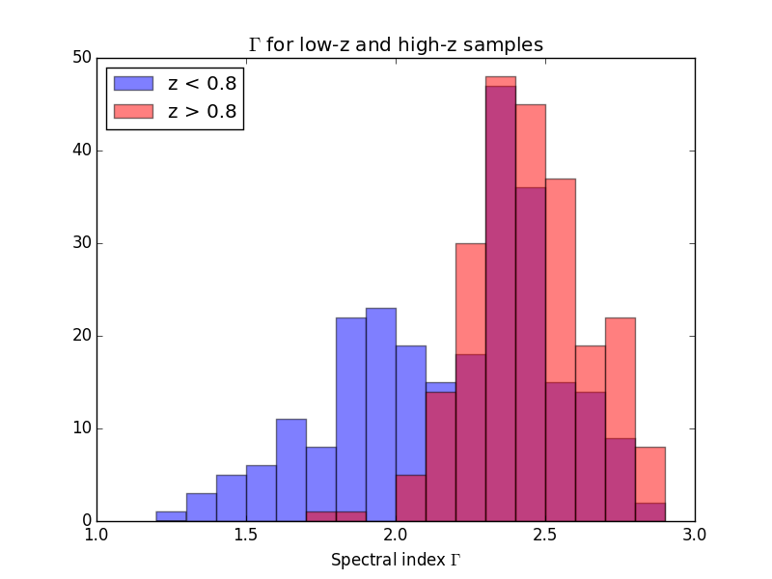
- Curve Fitting with Scipy

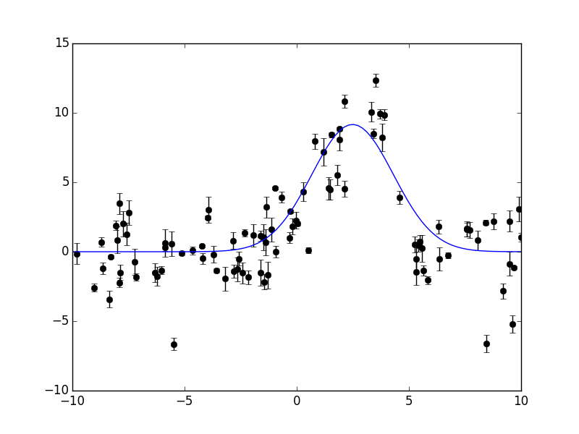
- Synthetic Images

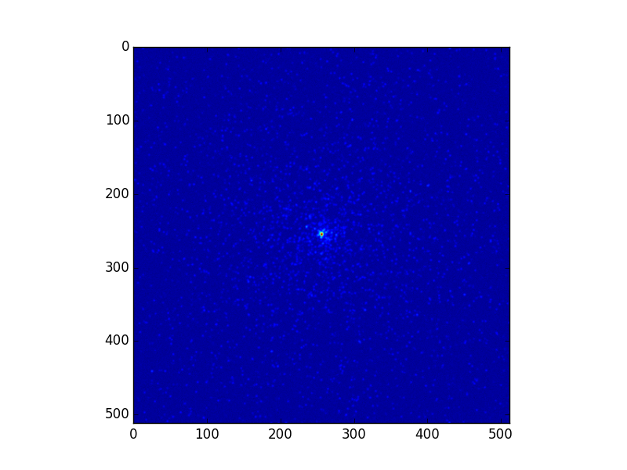

- Manipulating galaxy images.

The following plot gives the wavelength range of u,g,r band as well as i,z.

Filter λmean λeff λmin λmax Weff
u 3561.8 3594.9 3048 4028 558.4
g 4718.9 4640.4 3783 5549 1158.4
r 6185.2 6122.3 5415 6989 1111.2
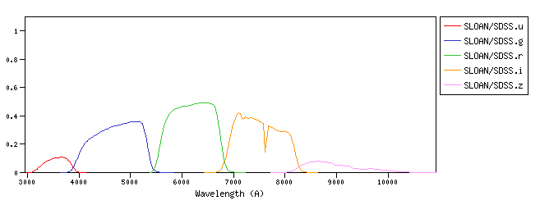
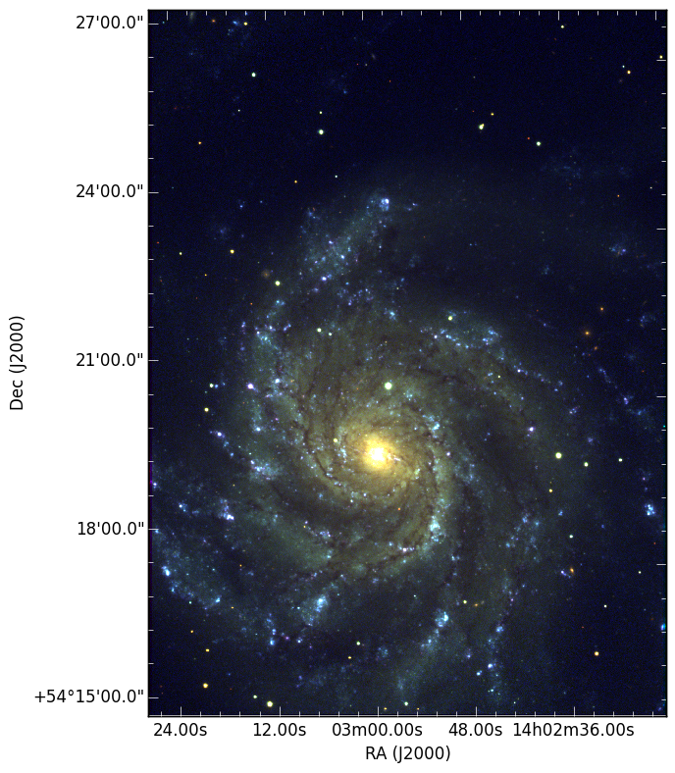

A typical human eye will respond to wavelengths from about 3900-7000 angstrom and we know the light can be decomposed into three colors red, green and blue. So we can create the pseudo-RGB color image with three different energy images respectively correspond to red, green and blue colors.

4.Exploring galaxies in the SDSS
Exercise 1: Look at the following galaxies. Divide them into groups based on features they have in common. There is no set number of groups.

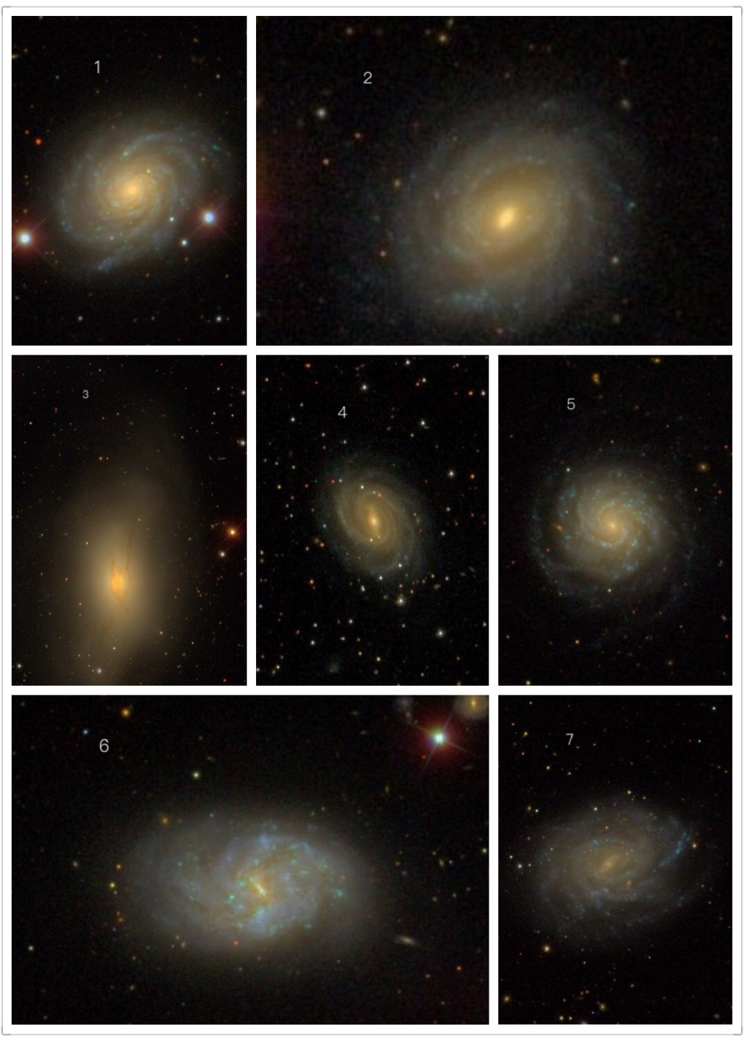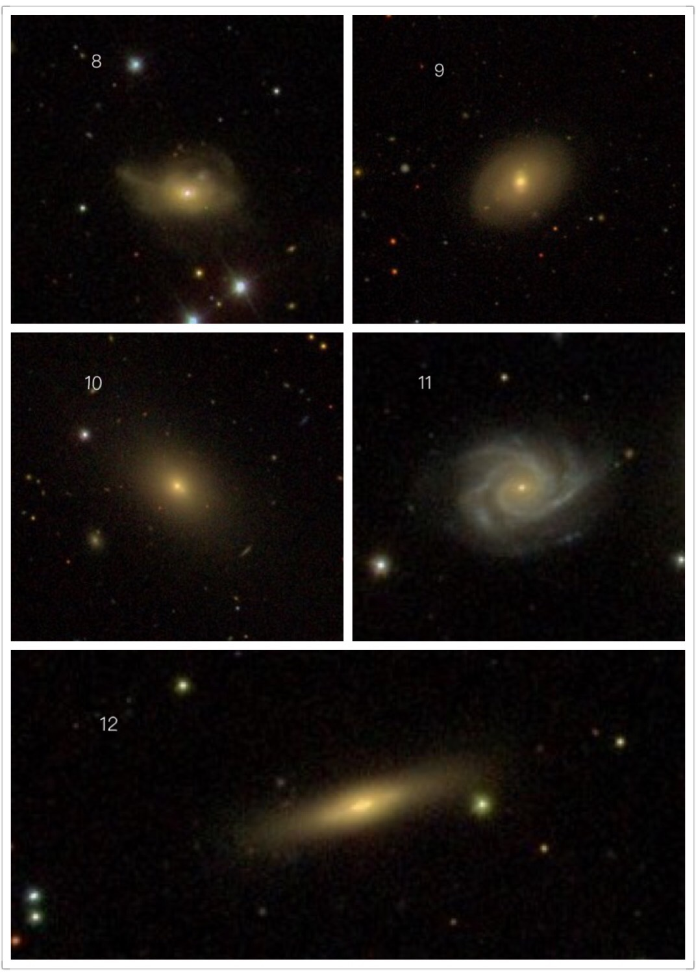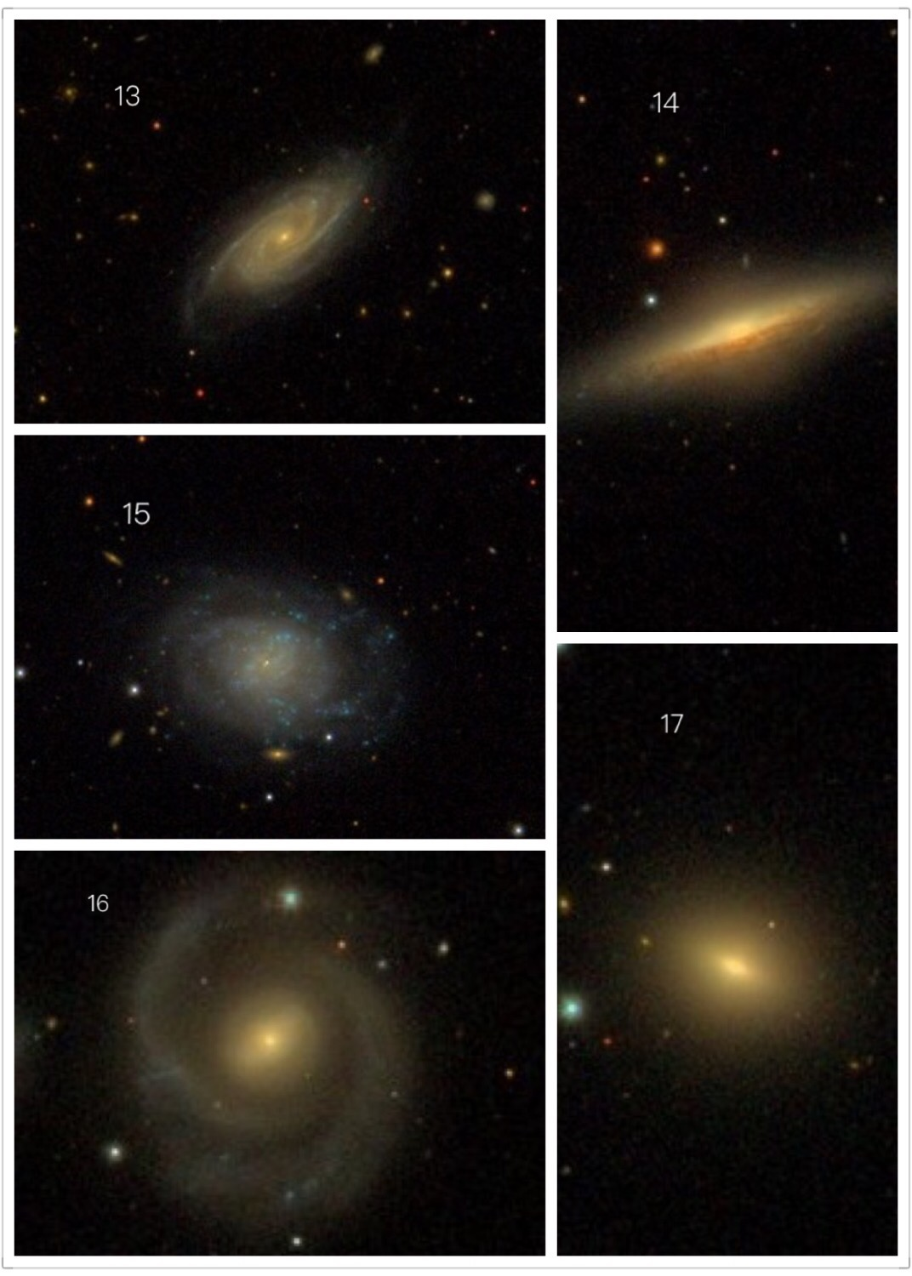

(For discussion convenience, I cut the images, put them together, gave them symbol numbers and distributed them to my group partners.)

Classification:
Type1 with spiral structure: 1,2,4,5,6,7,11,13,15,16
Type2 elliptical with central bright spot: 9,10,17
Type3 flat:12,14
Type4 others 3,8

Exercise 2: Go back to the galaxies you looked at in Exercise 1, shown again in the table below. Classify them on the Hubble Tuning Fork.

Spirals: 1,2,4,5,6,7,11,13,15,16
Ellipticals: 9,10,12,14(S0?),17
Irregular: 3,8

Exercise 3.

The galaxy I selected are as follow(the .csv file):

objid,type,ra,dec,u,g,r,i,z,redshift
1237671939804561466,GALAXY,258.14536146992,64.0707039556691,17.96586,15.43528,14.45425,13.74995,13.69962,Null
1237671939804561474,GALAXY,258.067495327645,64.0367718751392,19.88776,17.80275,16.81038,16.36799,16.01531,Null
1237671939804561475,GALAXY,258.213356620306,64.0731695837472,19.24982,17.20155,16.26258,15.75252,15.49401,0.07390616
1237671939804561476,GALAXY,258.119946070518,64.0607482946166,17.35083,14.94665,14.0375,13.56921,13.33719,0.0734653
1237671939804561477,GALAXY,258.10598183411,64.0221140024903,19.61755,17.57909,16.65882,16.26594,15.9918,Null
1237671939804561484,GALAXY,258.181636220846,64.0535395506805,19.60752,17.72213,16.78737,16.35058,16.07873,0.08562605
1237671939804561487,GALAXY,258.080537265349,64.0356334104144,18.81614,16.63012,15.65813,15.25769,15.02383,0.08261043
1237671939804561640,GALAXY,258.258457871243,64.0522970986782,17.98511,15.83024,14.83095,14.39797,14.0908,Null
1237671939804561642,GALAXY,258.24026130708,64.0510324043104,19.98869,18.03933,17.15539,16.76332,16.51385,0.07399645
1237671939804561830,GALAXY,257.991871547624,64.0891510021973,18.8715,16.84598,15.92457,15.48088,15.13799,0.07971801
1237671939804561927,GALAXY,258.135151517819,64.0028043403084,18.50986,16.514,15.54687,15.11602,14.77579,0.08500046
1237671939804561999,GALAXY,258.230950983658,64.032409038412,19.74761,18.29159,17.63881,17.27,17.15743,0.08127932
1237671939804627298,GALAXY,258.335387493843,64.0094516824416,18.47042,17.77927,17.64785,17.43055,17.42111,0.0798867
1237671939804627306,GALAXY,258.340516630173,64.0690707331199,18.71745,16.65773,15.71131,15.28201,14.95813,0.0761909
1237671939804627378,GALAXY,258.391298041976,64.0133828559746,18.49996,16.50575,15.53279,15.13875,14.79913,0.08209191
1237671939804627468,GALAXY,258.463305483247,64.0035185573993,18.23261,16.988,16.32518,15.93572,15.71291,0.08765244
1237671939804627594,GALAXY,258.296719025447,64.015460149115,20.7821,18.80833,17.75825,17.26745,16.84523,Null
1237671939804627716,GALAXY,258.363268143888,64.0035581135116,20.73138,19.74269,19.03925,18.6573,18.42551,Null

I think we need the information of redshift of the galaxy to determine to get the distance and tell whether one galaxy belong to the cluster or not.
D = z*c/H where z redshift, c light speed, H universe constant
If we adopt H = 70 km/s/Mpc then we have D(z=0.08) = 343 Mpc
The nearest galaxy I have in my sample has D(z=0.0734) = 315 Mpc
The farthest galaxy I have in my sample has D(z=0.0876) = 375 Mpc

